Ideation Phase
Empathize & Discover

Date | 18 February 2026
Team ID | LTVIP2026TMIDS80016
Project Name | Flavour Fusion: AI- Driven Recipe Blogging
Maximum Marks | 4 Marks

Empathy Map Canvas:
An empathy map is a simple, easy-to-digest visual that captures knowledge about a user’s behaviours and attitudes.

It is a useful tool to helps teams better understand their users.
Creating an effective solution requires understanding the true problem and the person who is experiencing it. The exercise of creating the map helps participants consider things from the user’s perspective along with his or her goals and challenges.

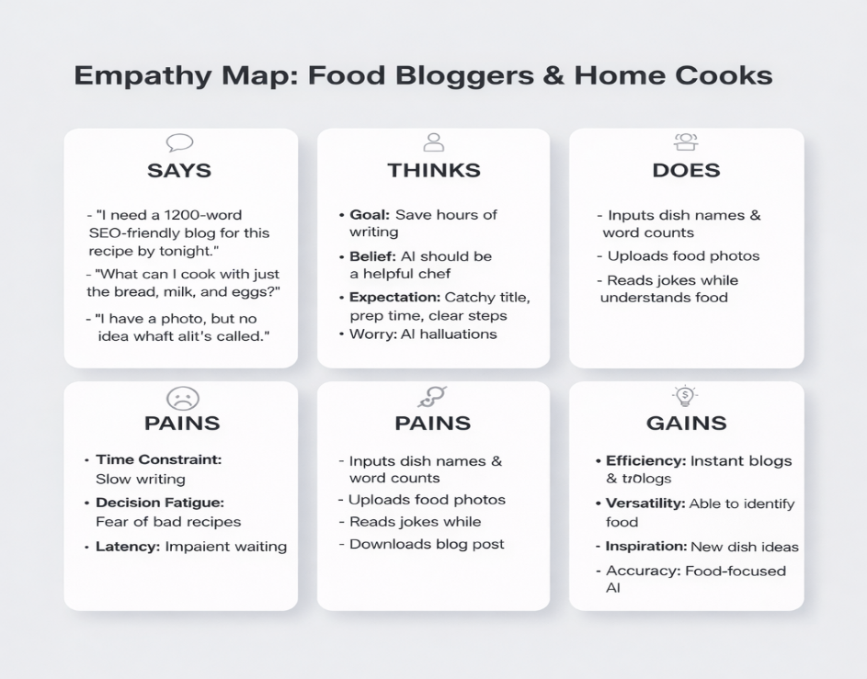
Example: Flavour Fusion: AI- Driven Recipe Blogging

This empathy map captures the lived experiences, motivations, frustrations, and aspirations of food bloggers and home cooks who regularly create, share, and search for recipes online. It is designed to inform the development of RecipeMaster, an AI-powered smart recipe blogging and food assistance system.
Through this map, we gain a deeper understanding of both the emotional and practical pain points of users—such as time pressure to publish SEO-friendly blogs, decision fatigue when choosing meals, fear of AI generating incorrect ingredients, and frustration with slow content creation processes. At the same time, it highlights their aspirations for fast, structured, reliable, and food-focused Assistance.

By documenting:
• What users think and feel (“Will this blog rank well?”, “Can I trust this recipe?”),
• What they hear (“Your recipe needs better formatting and SEO optimization”),
• What they say and do (“I spend hours writing and formatting my recipe posts”),
• What they need to do (save time, generate structured content, identify dishes from ingredients or photos, maintain accuracy),
we are able to design solutions that align with real-world needs and emotional drivers.
This exercise ensures that the AI model we build is not just capable of generating text, but is structured, culinary-focused, and trustworthy. It helps us create a system that supports users in generating professional recipe blogs instantly, discovering dishes from limited ingredients, identifying food from images, and reducing creative fatigue.
Ultimately, RecipeMaster aims to empower food bloggers and home cooks to create high-quality culinary content faster, make confident cooking decisions, and transform the recipe creation process into an efficient, engaging, and inspiring experience.

